Another function:

Compare. Since this is car purchasing, user probably need compare several cars to determine which one to buy. So compare function is very important for this project. After the user searching for what kinds of car he wants to buy, there will be a list of cars that satisfied his searching key word. Looks like this: 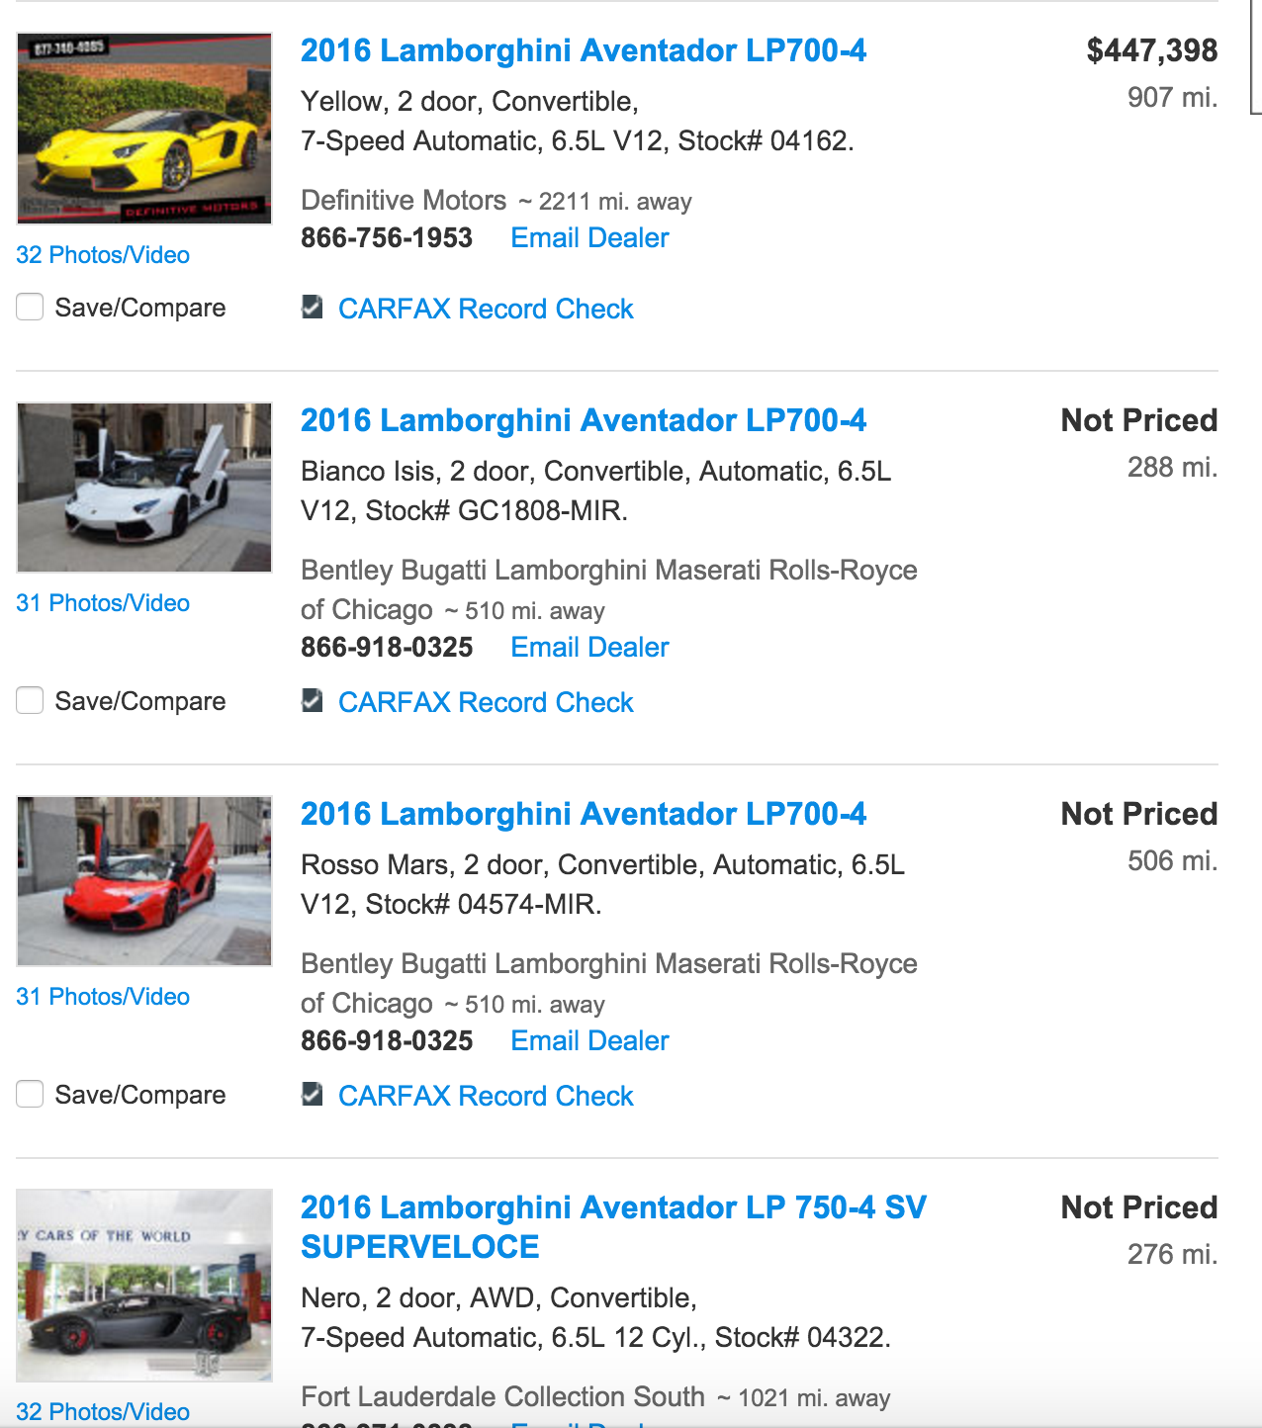

Then user can mark several cars as compare. On the top of website there will be a button “compare”. By clicking this button the website will generated a table shows the data of the marked cars’ entities.